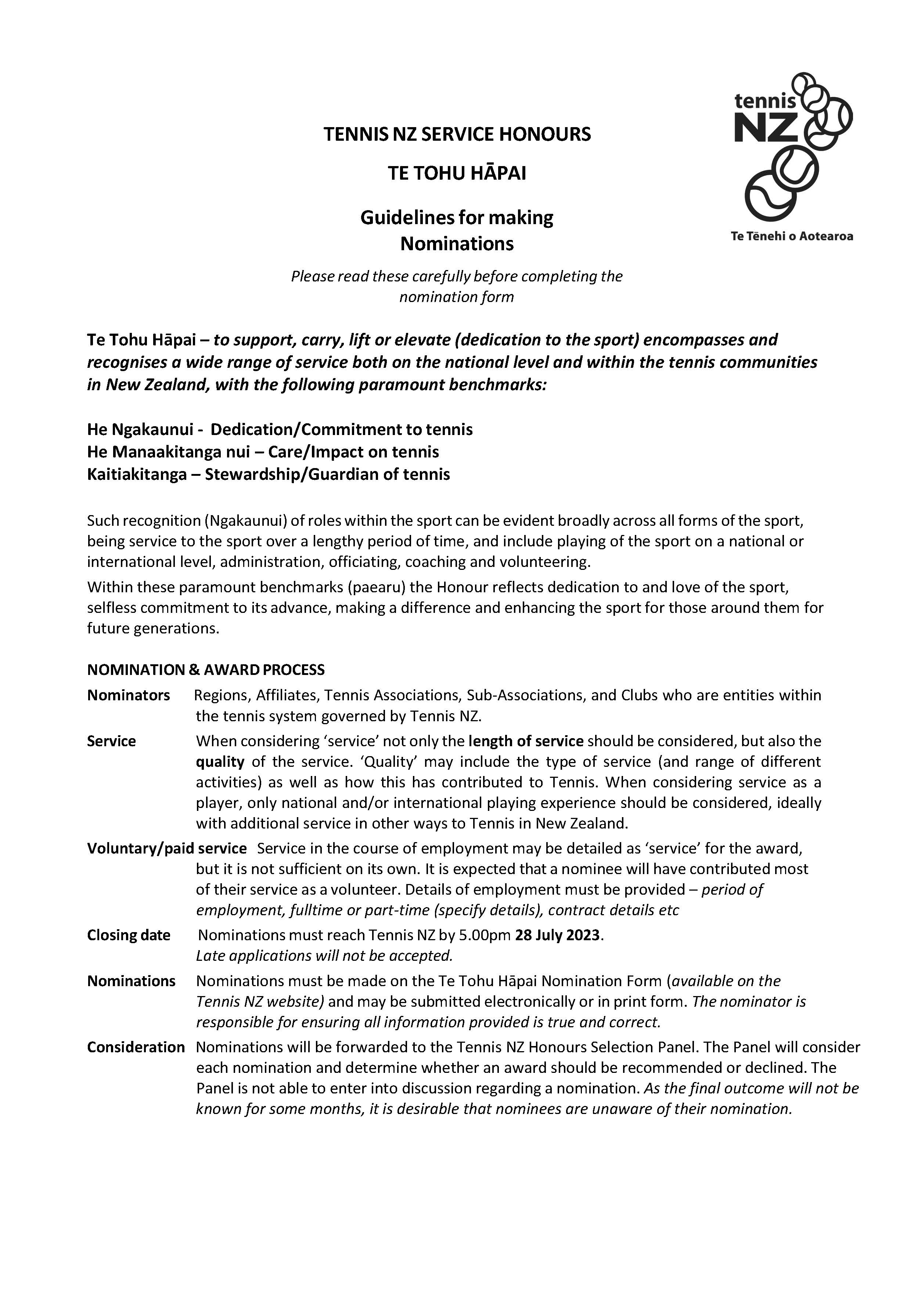

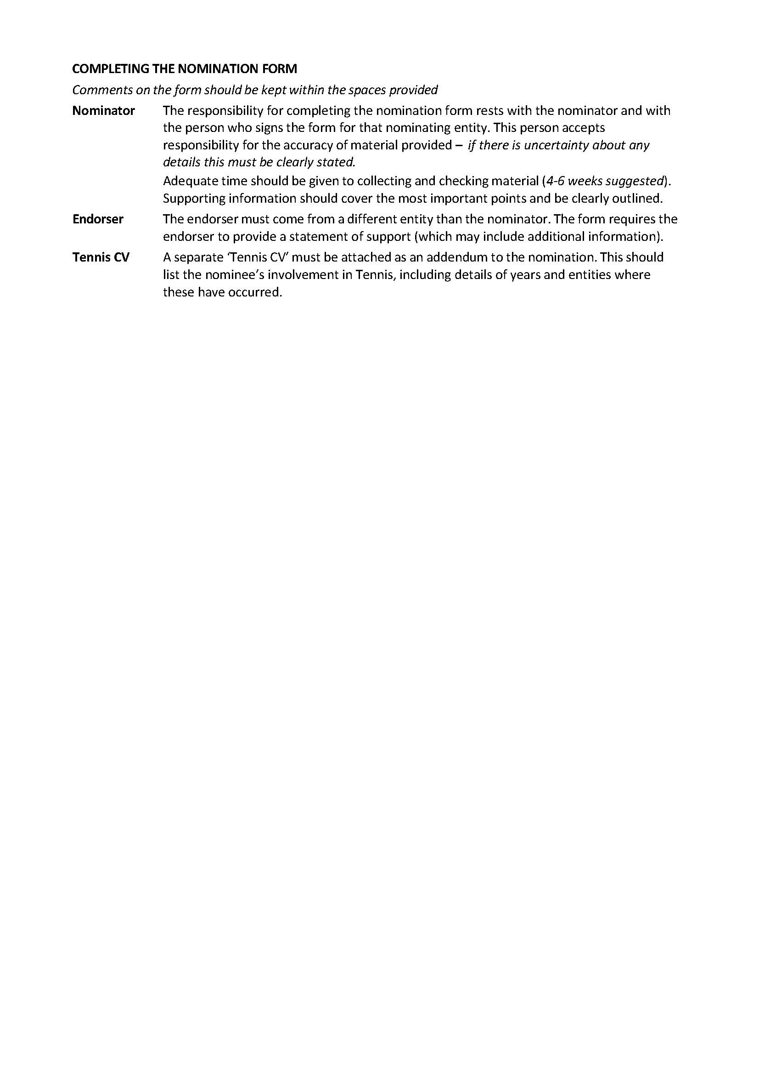


 |  | NOMINATION FOR TE TOHU HĀPAI  (SERVICE HONOURS)  Please read the accompanying nomination guidelines before completing this form
Section 1: Details of Nominee
Full Name of Nominee
Also known as
Address
Email Address
Awards for service to Tennis | Name of Award |  |  | Award  date
List any local awards for Tennis
e.g. life membership, service award, regional/civic awards
List any national/international
awards for Tennis
e.g. Royal Honours, TNZ/INF awards
List any national/international
Tennis qualifications
e.g. NZ Coaching Award, International or NZ Umpiring Award etc
List details of any Tennis employment
Indicate if these are full-time, part- time positions or short- term contracts
Section 2: Information about the Nominator
Name |  |  | Position
Name of Nominating Entity
Contact Address
Contact telephone |  |  | Mobile
Email address

2022

Section 3: Record of Service to support Te Tohu Hāpai Award Nomination
If service has occurred in more than one entity (refer Section 2), submit a SEPARATE page for each entity.
Name of Nominee
Title of Nominator
Paid work may be included in any section, but the contribution needs to exceed this. Please indicate clearly
service that is paid work. If you are unable to verify any information please mark this with an asterisk (*).
PLAYER (Please only complete the player panel if referring to service on a national or international level and add only other forms of service below)
Level | Details | Dates
OFFICIATING
Level | Details | Dates
COACH/MANAGER/TEAM OFFICIAL
Level | Details | Dates
ADMINISTRATION
Level | Details | Dates
OTHER
Level | Details | Dates
I have marked any items that I am unable to verify with *. The reasons for this are:
On behalf of the above entity I verify that the above information is correct.
Signed | Position
Name | Date

Section 4 – Check List for Sending Nomination
Has all necessary information been completed on the form?
Has the nominator signed the form?
Have you attached a Tennis CV for the nominee?

PLEASE SEND THIS FORM AND ANY ATTACHMENTS TO

Honours Selection Panel  Tennis New Zealand Box 300 130  Albany  Auckland 0632 | Telephone: (09) 528-5428 Email: admin@tennis.kiwi  Nominations close at 5.00pm on 28 July 2023  Late applications cannot be accepted

2022

