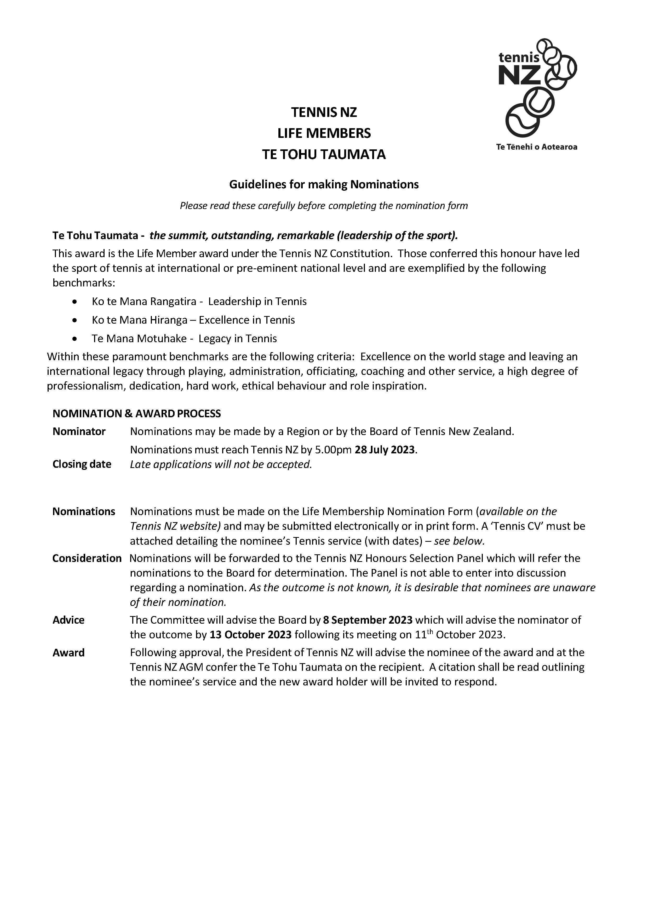

|  |  |
| --- | --- |
|  | **NOMINATION FOR TE TOHU TAUMATA MEMBERSHIP**  **(HONORARY LIFE MEMBERSHIP)**  **Please read the accompanying nomination guidelines before completing this form** |

|  |  |  |  |  |  |  |
| --- | --- | --- | --- | --- | --- | --- |
| **SECTION 1 – Information about the Nominee (the person you are nominating)** | | | | | | |
| Full name |  | | | | | |
| Also known as |  | | | | | |
| Street/Apartment No |  | | Street name |  | | |
| Suburb |  | | | City/town |  | |
| Post code |  | | Contact phone |  | | |
| Email address |  | | | | TNZ Service Award (*award year*) |  |
| List any **local awards** for Tennis  *e.g. life membership, service award, regional/civic awards* | |  | | | | |
| List any **national/international** awards for Tennis  *e.g. Royal Honours, Tennis NZ/INF awards* | |  | | | | |
| List any **national/international** Tennis qualifications  *e.g. NZ Coaching Award, International or NZ Umpiring Award etc* | |  | | | | |
| List any **national/international** Tennis appointments/positions/offices held *give details* | |  | | | | |
| List details of any Tennis employment  *Indicate if these are full-time, part-time positions or short-term contracts* | |  | | | | |

|  |  |  |  |
| --- | --- | --- | --- |
| **SECTION 2 – Information about the Nominator** | | | |
| Name |  | Position |  |
| Name of Zone/Centre | *(nominations may made by a zone, centre or Tennis NZ Board)* | | |
| Contact address |  | | |
| Contact telephone |  | Mobile |  |
| Email address |  | | |

**SECTION 3 – Nomination details** *(please complete all sections)*

1. **Describe the contribution the nominee has made to Tennis in the local area**
2. **Describe the contribution the nominee has made to Tennis nationally**
3. **Describe the contribution the nominee has made to Tennis internationally**
4. **Describe how the nominee stands out from others**

**Nominator’s signature Date**

**Section 4 – Check List for Sending Nomination**

⇨ *Has all necessary information been completed on the form?*

⇨ *Has the nominator signed the form?*

⇨ *Have you attached a Tennis CV for the nominee?*

PLEASE SEND THIS FORM AND ANY ATTACHMENTS TO

|  |  |
| --- | --- |
| Honours Committee  Tennis New Zealand PO Box 300 130  Albany, Auckland 0632 | Telephone: (09) 528 5428 Email: [admin@tennis.kiwi](mailto:admin@tennis.kiwi)  ***Nominations close at 5.00pm on 28 July 2023***  *Late applications cannot be accepted* |